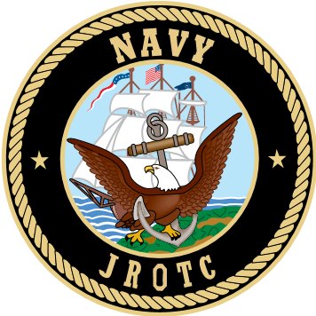
Rockport-Fulton High School NJROTC
1801 Omohundro Street • Rockport, Texas 78382 • (361) 790-2220 ext. 2141

December 2, 2024

Dear Parents, Guardians, and Family Members of Rockport Fulton Navy Junior ROTC Cadets,

I would like to cordially invite you to attend our Annual Military Inspection (AMI), which will take place on Wednesday, December 11, 2024 at the High School Competition Gym. Your cadets will be conducting a personnel inspection, marching and drill skills followed by a “Pass in Review” at 10 AM. The Annual Military Inspection highlights the culmination of hard work our cadets have dedicated to the Rockport Fulton Navy JROTC unit. They will showcase their newfound basic military knowledge, discipline, and their ability to drill. Upperclassmen will exhibit their teaching and mentoring skills during drill and inspection. Above all they will show growth, leadership, and tenacity through discipline, hard work, and dedication. There will also be an unarmed exhibition and armed exhibition routine and awards presentation.

Please feel free to contact Chief BetancourtCantu or myself if you have any questions at (361)-790-2220 ext. 2141 or 2142.

Sincerely,

Christian Salas
Chief Petty Officer, Submarines, USN (Retired)
Senior Naval Science Instructor
Rockport Fulton High School Navy JROTC

